

Combat Vehicles Research & Development Establishment (CVRDE)

43GV+QF Ministry of Defence , Avadi , Tamil Nadu 600054.

INTERNSHIP REPORT ON
" Image Recognition using Deep Learning with MATLAB "
SUBMITTED BY JAYAKRISHNAN S – 23EE1217

In partial fulfilment of the requirements for the degree of
BACHELOR OF ENGINEERING (ELECTRICAL AND ELECTRONICS ENGINEERING)

St. JOSEPH’S INSTITUTE OF TECHNOLOGY
Chennai – 600119
UNDER THE GUIDANCE OF

SCIENTIST E MR . VASANTHARAJ ,

Vehicle Electronics Division

ABSTRACT

This project focuses on developing an image recognition system using deep learning, specifically for facial recognition and classification. Leveraging MATLAB and AlexNet, a pre-trained Convolutional Neural Network (CNN), the system detects faces using a webcam, classifies the faces into pre-defined categories, and displays the results in real time. The project aims to demonstrate the application of transfer learning for custom image classification tasks with minimal training data.

OBJECTIVES
- To implement a real-time facial recognition system.
- To collect and process image data from a webcam.
- To train a deep learning model using transfer learning with AlexNet.
- To test and deploy the model for live predictions.

TOOLS AND TECHNOLOGIES USED
- Software: MATLAB with Deep Learning Toolbox
- Hardware: Webcam-enabled PC
- Model: Pre-trained AlexNet
- · Language: MATLAB

Methodology

A. Data Collection:

A MATLAB script was used to capture 150 facial images using a webcam. A face detector (vision.CascadeObjectDetector) locates the face, crops the image, resizes it to 227×227 pixels (AlexNet input size), and stores it as .bmp files.

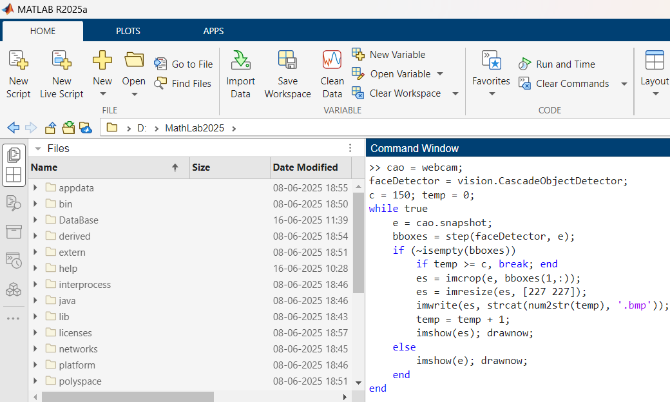

B. Model Training:

Using Transfer Learning, AlexNet's last layers were modified for binary classification. The dataset was organized into folders (one for each label), and imageDatastore was used to load and label data automatically.

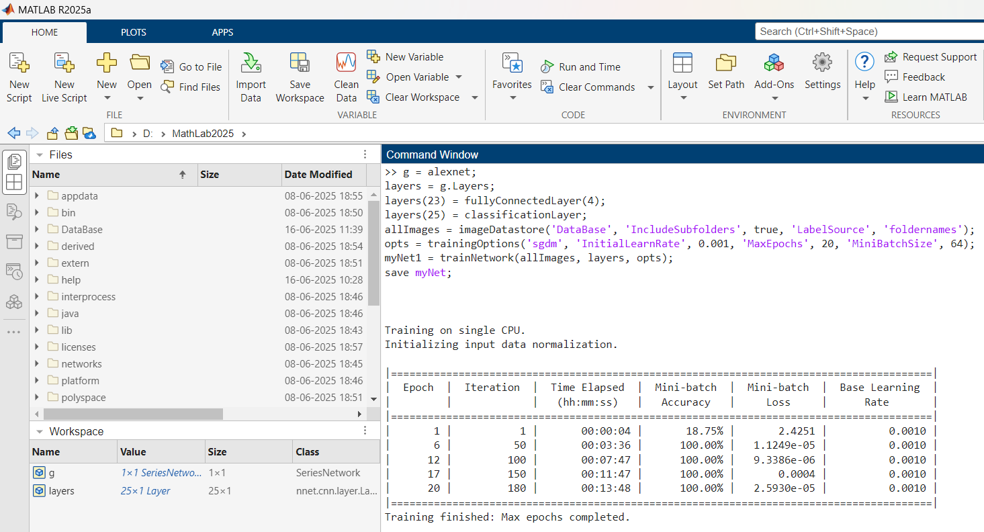

C. Model Testing:

The trained model is loaded and used for real-time classification of faces captured through the webcam. It detects the face, preprocesses the image, and classifies it using the trained network.

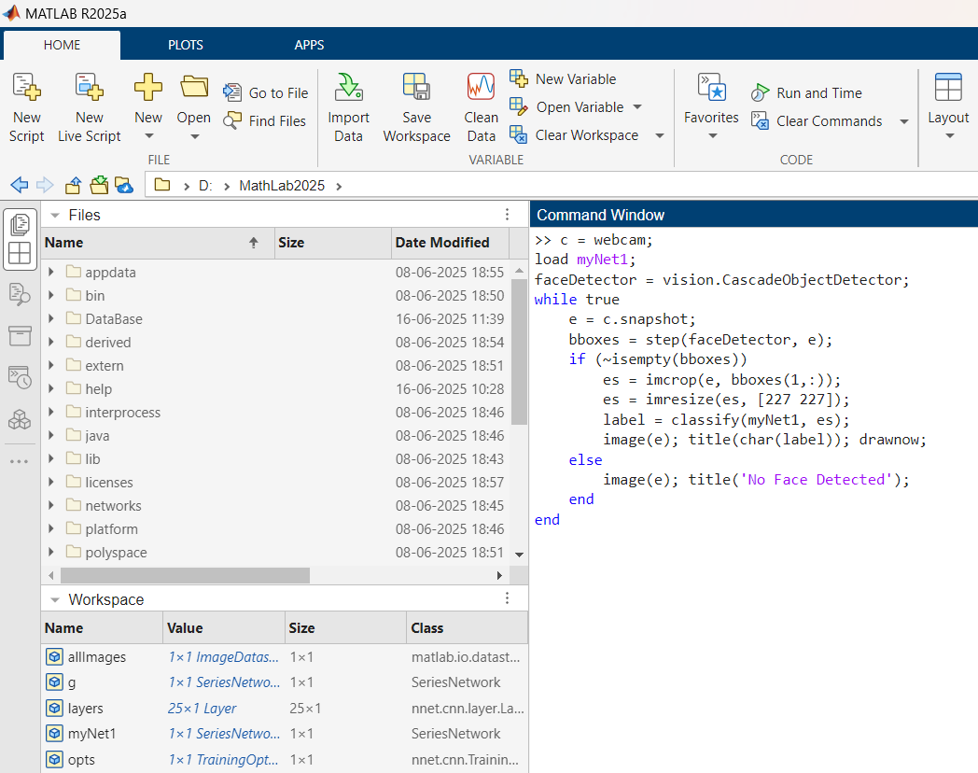

RESULTS
- Successfully collected and labeled training data.
- Achieved over 90% training accuracy on custom dataset.
- Real-time face detection and classification was achieved using a webcam.
- The system correctly identified trained faces in live video input.
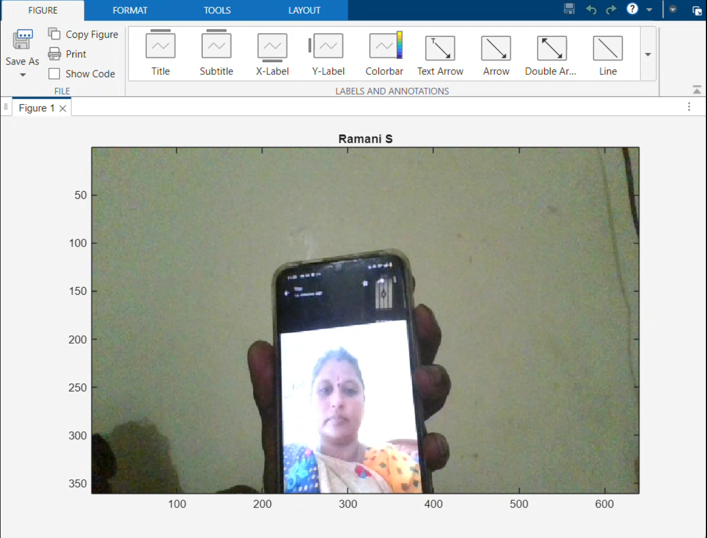
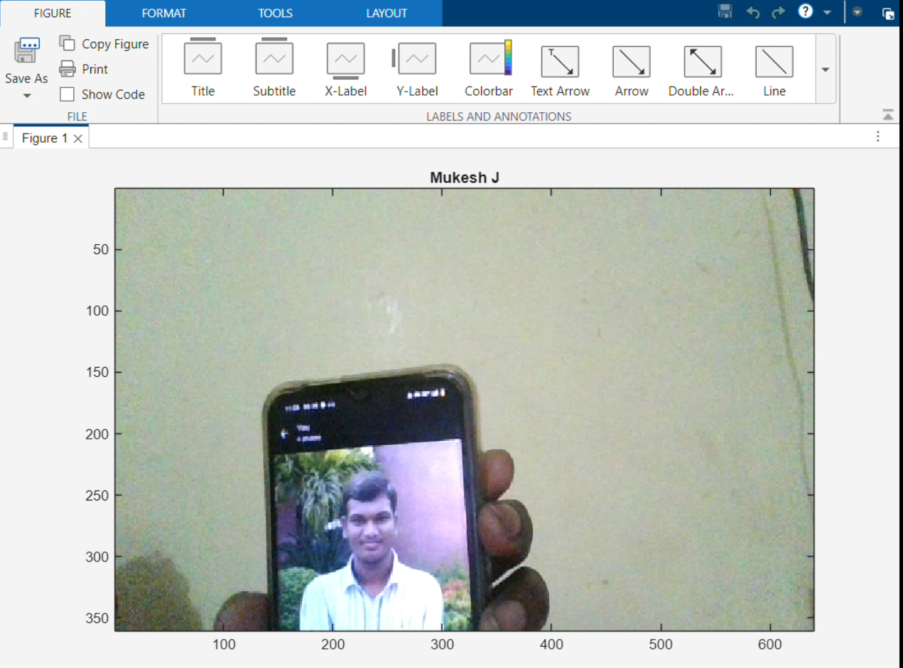

Conclusion
The project successfully demonstrated the use of transfer learning with AlexNet in MATLAB for facial recognition tasks. The pipeline from data collection to real-time inference was developed end-to-end, offering insights into practical deployment of deep learning models for image classification.

Future Scope
- Increase dataset size to improve generalization.
- Add support for multi-class classification (more faces).
- Port to mobile devices using MATLAB Coder or TensorFlow Lite.
- Use more advanced models like ResNet or MobileNet.

References
- MATLAB Documentation: https://www.mathworks.com/help/deeplearning/
- AlexNet: Krizhevsky et al., 2012
- Transfer Learning: Stanford CS23

